**Phase F: Usage Manual**

*Setting up the database*

A MySQL database must be running and a database must be created prior to usage of the program. Please consult the nearest database professor for how to set up a database server and create a database on the server. The program does not create a database or database server. When creating a database on the database server, **the name of the database must be “jupiter”.**

*Create the Tables and load the Data*

The tables must be created before the application can be run. Using MySQL workbench or something similar, run the createAll.sql on your running database to create tables in the database called jupiter. Again, **a database called jupiter must already be created.** Use your database program and call loadAll.sql to load sample data into the database.

*Getting the Program setup with the Database*

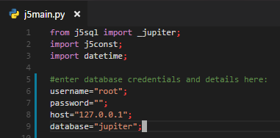

The program uses the python mysql connector module to connect to a mysql database. In order to do this, a **username, password, host address** must be provided by the user. These details must be entered near the top of the j5main.py file. Some defaults will already be there, it is safe to overwrite them with your own details.

*Running the Program*

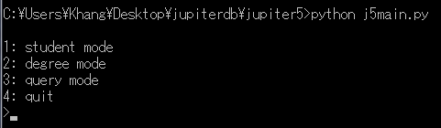

The program can be run by calling Python on the main python file, j5main.py, while all other python files are in the same directory (j5const.py and j5sql.py). Note that if the program fails to connect to the database, an error will have occurred at this point. Please re-check your inputted credentials. Additionally, please make sure to have the most update version of Python, and to install any missing modules.

*General Usage Warnings*

The UI of the application was rather roughly (very roughly) made and as a result has a ‘few’ quirks. As we were not required to make a good UI, there are a few things to watch out for:

1. If an SQL error occurs, the program (should) not crash, and the transaction will not occur. Please make sure to carefully check for any error messages that appear, the program **does not** pause to show messages, the message will appear, and the program will continue.
2. Many prompts will request that something be “selected”. In pretty much all cases this means to enter an **integer** that corresponds to one of the choices visible above, but not necessarily *directly* above. For many of these prompts, the program will **crash** if given an incorrect input (out of range, not an integer, not one of the choices), so please be careful.
3. Many operations are **not cancellable**. This means that if you accidentally select it, you will have to either complete the operation or close the program. Luckily, it is generally easy to recover from these choices.
4. Concerning delete menu choices: they will either delete the currently selected item, or prompt to delete an item from a list above. I tried to make sure this is specified, but might have missed some prompts. In either case, most delete prompts **do not ask for confirmation**. Since deletes cascade, quite a decent amount of data may be lost by an accidental delete. Please be careful around delete choices.
5. It is **highly** recommended for the sample data to be loaded before using the program. The menus of the program were not designed for empty menus, for example the program will have to be closed should you try to select something when there is nothing to select. It is of course possible to use the program starting with an empty database, however, be warned that **many choices will lead to dead ends**, requiring the UI to be closed.
6. The UI is not guaranteed to work correctly given incorrect user input.
7. The database and its data should not be damaged should the program crash, so feel free to close the program via keyboard interrupt at any time. Often times, this may feel like the fastest way to get to the main menu when deep in submenus.

*The main screen*

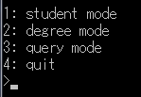

Once the program is running, you will be presented with the main screen. From this main screen you are able to navigate through menus in order to access various parts of the database.

***Degree Mode***

The degree mode has all the menus necessary to enter and modify details of a degree program in the database. It is recommended to start with this mode, as many operations in Student Mode require information created during Degree Mode.

*Degree Select*

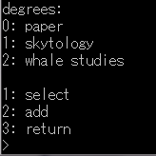

Degrees can be created on this screen. Additional information of the degree can be entered after selecting the degree.

*Selected Degree*

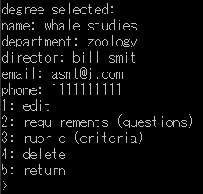

Here the user can edit the details of the degree, enter requirement questions, and set criteria. Selecting “delete” **will delete the currently selected degree.**

*Selected Degree->Requirements Mode*

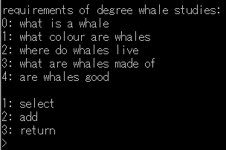

Selecting the requirements option shows the requirement questions for the currently selected degree. To add a new requirement, select the add option and enter the question of the requirement. To edit the requirement, delete the requirement, and add answers, simply select the requirement using the select choice. There is no option to edit answers – as it does not matter what order answers come in, simply delete the offending answer and add a new one. This is is equivalent to editing an answer. Displayed below is the screen upon selecting a requirement:

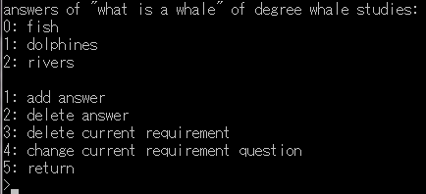

*Selected Degree->Rubric Mode*

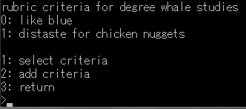

The rubric of a degree consists of its criteria. In this menu criteria can be added and selected in a similar manner to requirements. You will be prompted to enter the description of a criteria when creating one. Once a criteria is made and selected, scores can be assigned to the criteria in a similar manner to requirement’s answers, the difference being a score has a description and a condition. The two fields of a score can be edited by selecting the relevant choice. When prompted to choose a number of a score, enter the number to the left of the score as it appears on the list above the menu prompts. Displayed below is the screen upon selecting a criteria:

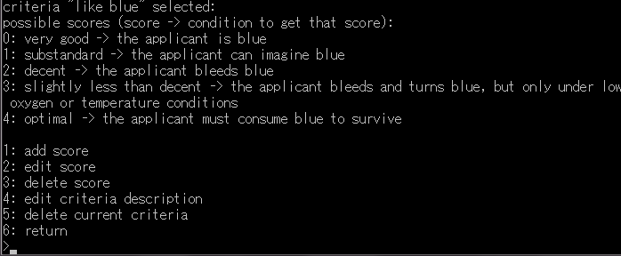

***Student Mode***

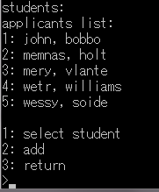

*warning:* once a create student operation has begun, it cannot be cancelled without ending the program. If you did not want to create a student, please follow through the process with arbitrary information to create a student, this student can be deleted later.

Students can be selected and created here. Phone numbers for a student can be added after the student is selected. When selecting a student, **type the number to the left** of the student desired.

*Selected Student Mode*

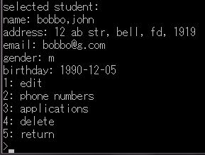

On this screen the phone numbers of a student can be added, and applications can be made.

*Adding an Application*

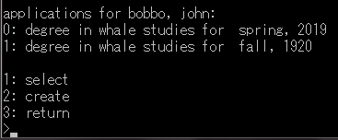

When adding an application, the user will be prompted to select a degree that had been created in the degree mode. If no degrees are present, refer to General Warning 5. Select the application after it has been created to begin adding more details.

*Application Mode*

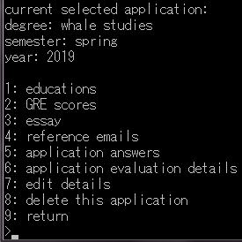

From this screen, application information can be entered. Select an option to navigate menus which are able to access the relevant information. A note for the submenus: in this part of the program, many of the submenus, when asking for the number of some item to edit or delete, will **crash the program given incorrect input**. Although the user should **already be watching out** for this, incorrect input is slightly more important in this section of the program. A reminder that this is the worst UI ever.

*Application Mode->Education*

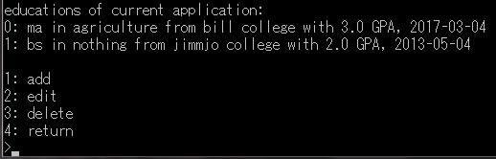

Applicant education can be entered here. Please note that although there are sql CHECKS in the table code, these checks do not actually work, so it may be possible to enter, if needed, GPA values above 4. However, this may lead to unexpected results when performing queries, so do so at your own risk. The delete and edit options on this menu will ask for a number, input the number immediately to the left of the desired education to perform the action upon it.

*Application Mode->GRE scores*

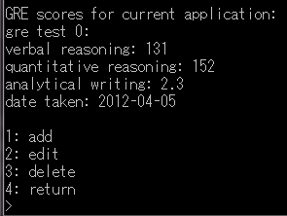

The GRE mode is functionally identical to the education mode; it simply deals with different information. Although there are CHECK statements for the GRE score ranges, they do not work, and so the GRE scores entered are not checked for valid-ness. Enter illogical scores at your own risk.

*Application Mode->Essay*

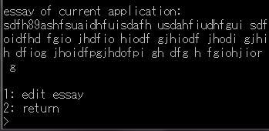

The essay for the application can be viewed and edited here. It is separate as logically essays should be long, and would take up the screen if it weren’t in its own submenu.

*Application Mode->Reference Emails*

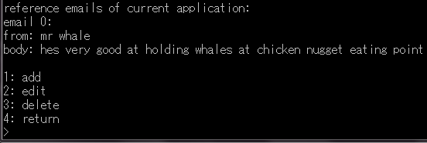

Reference Emails can be viewed, added, edited, and deleted here. Up to a maximum of three emails can be present at a time, please remove one if you have reached the limit.

*Application Mode->Answers*

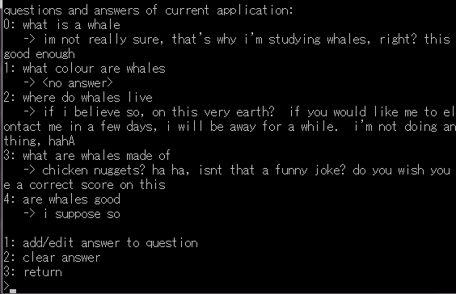

*Note: this screenshot is cutoff to save space*

Here, the user can supply answers to requirement questions of the degree the application is applying to. Every question is displayed immediately in this submenu; the user simply has to pick a question and type in their answer.

*Application Mode->Evaluation*

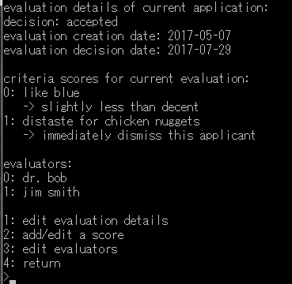

Evaluation things such as final decision, evaluation creation date, and evaluation decision can be entered here. Select “edit evaluation details” to change these fields. The criteria of the degree of the currently selected application is also visible here. By selecting “add/edit score”, scores can be assigned by evaluators. The scores available to assign are those created during Degree Mode->Rubric Mode. The score description will then appear below the criteria. Evaluator’s names can also be added at this time using the “edit evaluators” option. When attempting to delete an evaluator, refer to the number next to the evaluator’s name.

Note for user: Dates are expected to be valid, and may result in strange queries if illogical dates are entered. For example, it is expected that a decision is to be accompanied with a decision date. It is not possible to enforce these with the menu UI, where a user can edit both fields one at a time.

*Application Mode->Edit Details*

The details entered at the start of the application creation process may be corrected here.

*Application Mode->Delete Application*

*C:\Users\Khang\Desktop\delete.png*

This will **delete the currently selected application and data attached to it**. Fortunately, we are proud to announce this particular delete option does in fact provide confirmation. Do not expect it on any other options.

***Query Mode***

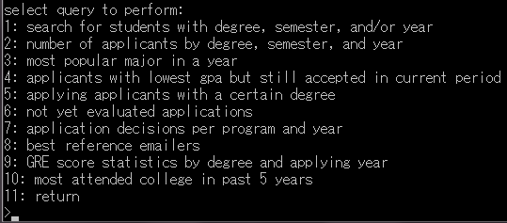

Queries can be executed here. The queries are ordered in the same order as the requirements, just in case the descriptions are confusing. For this part of the program, the program pauses after each query result so the user can take note of it. At these times, follow the on-screen prompt and press the **enter** key to continue. It must be the **enter** key. Some queries will prompt for a piece of information before continuing, please continue to heed the warnings of invalid user input for these prompts as well.